**ToDo project**

Create new folder ToDo.

python -m venv env

env\Scripts\activate

pip install Django

pip freeze(“to check Django is install”)

django-admin startproject todo_main . (“to create a project name todo_main”)

python manage.py runserver (“to check the default sserver is run”)

python manage.py migrate

python manage.py createsuperuser

Username (leave blank to use 'admin'): admin

Password: 123

Login in the ([Site administration | Django site admin](Site%20administration%20|%20Django%20site%20admin)) <http://127.0.0.1:8000/admin/>

ToDo\todo_main\urls.py

from django.contrib import admin

from django.urls import path

from . import views

urlpatterns = [

    path('admin/', admin.site.urls),

    path("",views.home,name="home")

]

To create ToDo\todo_main\views.py file

In views.py

from django.http import HttpResponse

def home(request):

    return HttpResponse("home page")

check the home page print in 127.0.0.1:8000

ToDo\todo_main\views.py file

In views.py

from django.shortcuts import render

def home(request):

    return render(request,'home.html')

create a new folder ToDo\templates\home.html

<h2> This is homepage</h2>

In settings.py

TEMPLATES

'DIRS': ['templates'],

check the This is homepage print in 127.0.0.1:8000

change ToDo\templates\home.html

{% load static %}

<!DOCTYPE html>

<html lang="en">

<head>

    <meta charset="UTF-8">

    <meta http-equiv="X-UA-Compatible" content="IE=edge">

    <meta name="viewport" content="width=device-width, initial-scale=1.0">

    <title>TODO LIST - Home</title>

    <!-- Bootstrap -->

    <link href="https://cdn.jsdelivr.net/npm/bootstrap@5.3.0-alpha1/dist/css/bootstrap.min.css" rel="stylesheet" integrity="sha384-GLhlTQ8iRABdZLl6O3oVMWSktQOp6b7In1Zl3/Jr59b6EGGoI1aFkw7cmDA6j6gD" crossorigin="anonymous">

    <script src="https://cdn.jsdelivr.net/npm/bootstrap@5.3.0-alpha1/dist/js/bootstrap.bundle.min.js" integrity="sha384-w76AqPfDkMBDXo30jS1Sgez6pr3x5MlQ1ZAGC+nuZB+EYdgRZgiwxhTBTkF7CXvN" crossorigin="anonymous"></script>

    <!-- Font Awesome Icons -->

    <link rel="stylesheet" href="https://cdnjs.cloudflare.com/ajax/libs/font-awesome/4.7.0/css/font-awesome.min.css">

    <style>

        .form-control{

        padding: 1.375rem .75rem !important;

    }

    </style>

</head>

<body>

    <div class="container">

        <h3 class="pt-5 text-center">Django ToDo App</h3>

        <div class="row">

            <h4>My Day</h4>

            <p class="text-muted">{% now "jS F Y" %}</p>

            <div class="col-md-7 col-lg-7" style="height: 450px; overflow: scroll;">

                <!-- List of all the tasks for the day -->

                <div class="card m-1">

                    <div class="card-body">

                        This is some Task

                        <span style="position: relative; float: right;">

                            <a class="btn btn-success"><i class="fa fa-check"></i> Mark as Done</a>

                            <a class="btn btn-danger"><i class="fa fa-trash"></i></a>

                            <a class="btn btn-primary"><i class="fa fa-pencil"></i></a>

                        </span>

                    </div>

                </div>

            </div>

            <div class="col-md-5 col-lg-5">

                <h5>Completed Tasks</h5>

                <!-- List of all the tasks that have completed -->

                <div class="card m-1">

                    <div class="card-body">

                        This is the completed task.

                    </div>

                </div>

            </div>

        </div>

        <div class="row">

            <div class="col-md-6 col-lg-6 p-0" style="position: absolute; bottom: 50px;">

                <!-- To Do Form -->

                <form action="" >

                    <div class="form-group">

                        <span style="display: flex;">

                            <input type="text" class="form-control" placeholder="Add a task">

                            <button class="btn btn-primary" style="width: 200px;"><i class="fa fa-plus"></i> Add</button>

                        </span>

                    </div>

                </form>

            </div>

        </div>

    </div>

</body>

</html>

check the This is home.html running in 127.0.0.1:8000

Create app In ToDo.

python manage.py startapp todo

go to settings.py and add todo

INSTALLED_APPS = [

    'todo',

]

Go to todo app in models.py

from django.db import models

class Task(models.Model):

    task=models.CharField(max_length=250)

    is_completed=models.BooleanField(default=False)

    created_at=models.DateTimeField(auto_now_add=True)

    updated_at=models.DateTimeField(auto_now=True)

    def __str__(self):

        return self.task

go to todo app in admin.py

from django.contrib import admin

from .models import Task

admin.site.register(Task)

python manage.py makemigrations

python manage.py migrate

Change in todo_main/views.py

from django.shortcuts import render

from todo.models import Task

def home(request):

    tasks=Task.objects.filter(is_completed=False)

    context={

        "tasks": tasks,

    }

    return render(request,'home.html',context)

change in home.html

<!-- List of all the tasks for the day -->

                {% for task in tasks %}

                <div class="card m-1">

                    <div class="card-body">

                        {{ task.task }}

                        <span style="position: relative; float: right;">

                            <a class="btn btn-success"><i class="fa fa-check"></i> Mark as Done</a>

                            <a class="btn btn-danger"><i class="fa fa-trash"></i></a>

                            <a class="btn btn-primary"><i class="fa fa-pencil"></i></a>

                        </span>

                    </div>

                </div>

                {% endfor %}

Run the server ([TODO LIST - Home](TODO%20LIST%20-%20Home)) <http://127.0.0.1:8000/>

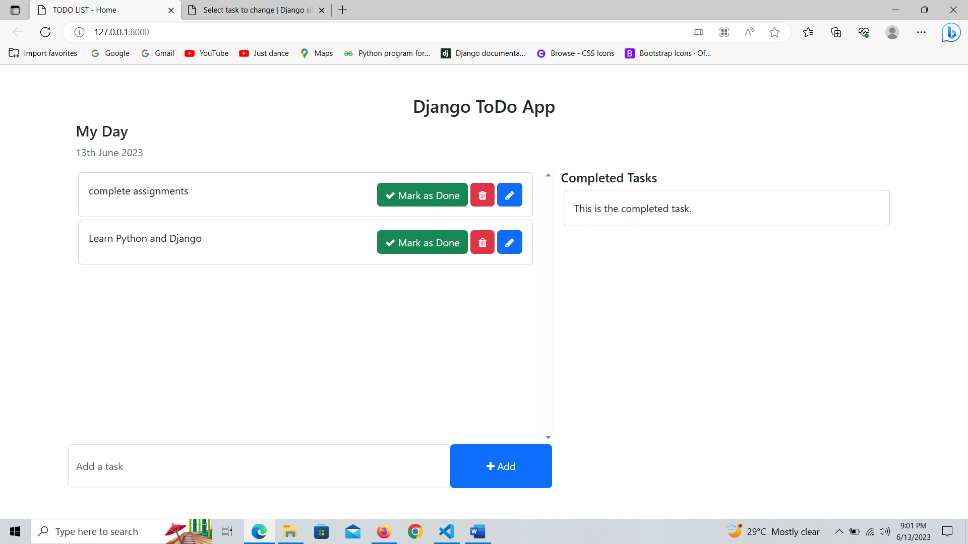

Change In todo app admin.py

from django.contrib import admin

from .models import Task

class TaskAdmin(admin.ModelAdmin):

    list_display=('task','is_completed','updated_at')

    search_fields=('task',)

admin.site.register(Task,TaskAdmin)

Run the server ([Select task to change | Django site admin](Select%20task%20to%20change%20|%20Django%20site%20admin))

<http://127.0.0.1:8000/admin/todo/task/>

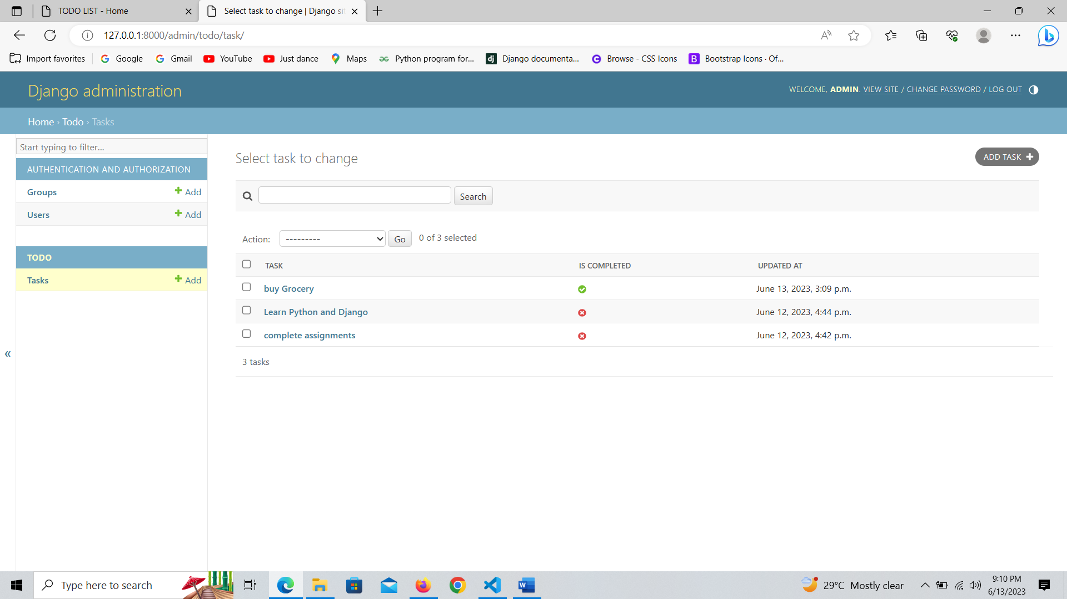

Change in todo_main urls.py

from django.contrib import admin

from django.urls import path, include

from . import views

urlpatterns = [

    path('admin/', admin.site.urls),

    path("",views.home,name="home"),

    #TO DO

    path('todo/',include('todo.urls')),

]

Create a file in todo app in urls.py

from django.urls import path

from . import views

urlpatterns = [

    path('addTask/', views.addTask,name="addTask"),

]

Todo app in views.py

from django.shortcuts import render, redirect

from django.http import HttpResponse

from .models import Task

def addTask(request):

    task=request.POST['task']

    Task.objects.create(task=task)

    return redirect('home')

change in home.html

<!-- To Do Form -->

                <form action="{% url 'addTask' %}" method="POST">

                    {% csrf_token %}

                    <div class="form-group">

                        <span style="display: flex;">

                            <input type="text" name="task" class="form-control" placeholder="Add a task">

                            <button type="submit" class="btn btn-primary" style="width: 200px;"><i class="fa fa-plus"></i> Add</button>

                        </span>

                    </div>

                </form>

Change todo_main in views.py

from django.shortcuts import render

from todo.models import Task

def home(request):

    tasks=Task.objects.filter(is_completed=False).order_by('-updated_at')

    context={

        "tasks": tasks,

    }

    return render(request,'home.html',context)

change in todo_main in views.py

from django.shortcuts import render

from todo.models import Task

def home(request):

    tasks=Task.objects.filter(is_completed=False).order_by('-updated_at')

    completed_tasks=Task.objects.filter(is_completed=True)

    context={

        "tasks": tasks,

        "completed_tasks":completed_tasks,

    }

    return render(request,'home.html',context)

change in home.html

<!-- List of all the tasks that have completed -->

                {% for task in completed_tasks %}

                <div class="card m-1">

                    <div class="card-body">

                       {{ task.task }}

                    </div>

                </div>

                {% endfor %}

            </div>

Run the server ([Select task to change | Django site admin](http://127.0.0.1:8000/admin/todo/task/)) <http://127.0.0.1:8000/admin/todo/task/>

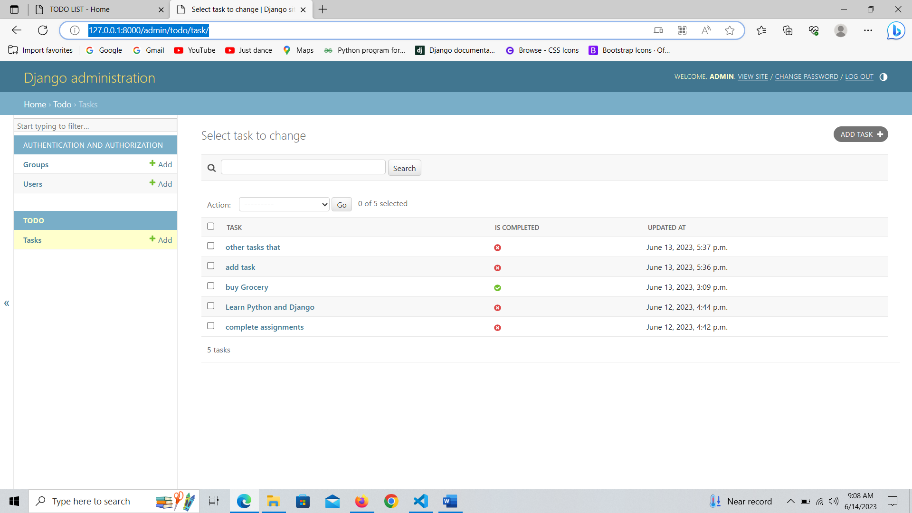

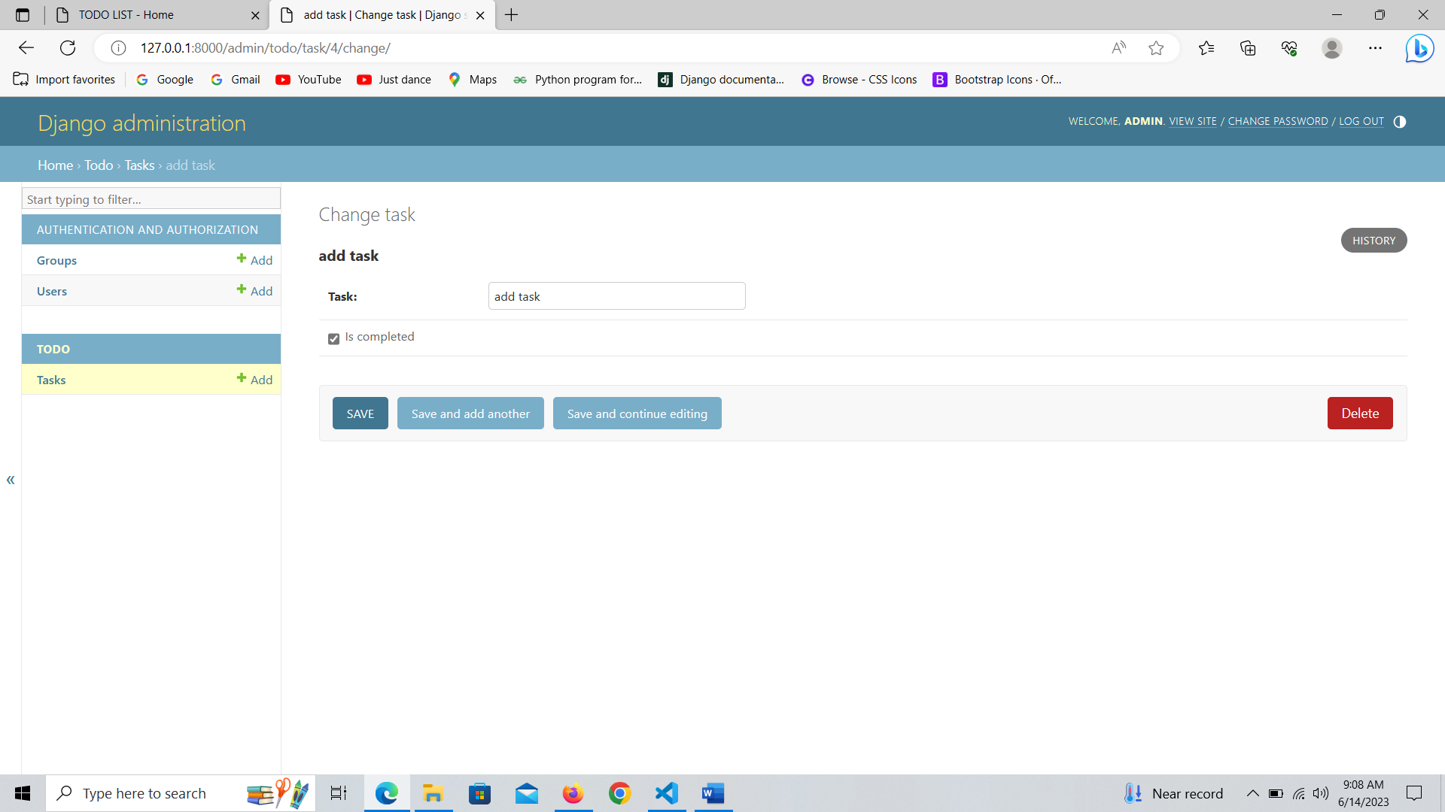

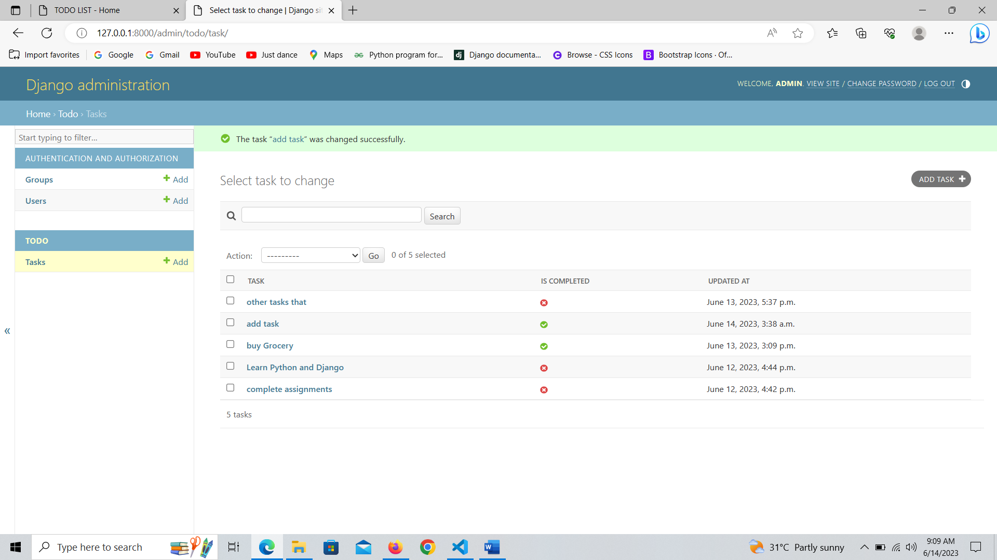

Run the server ([TODO LIST - Home](TODO%20LIST%20-%20Home)) <http://127.0.0.1:8000/>

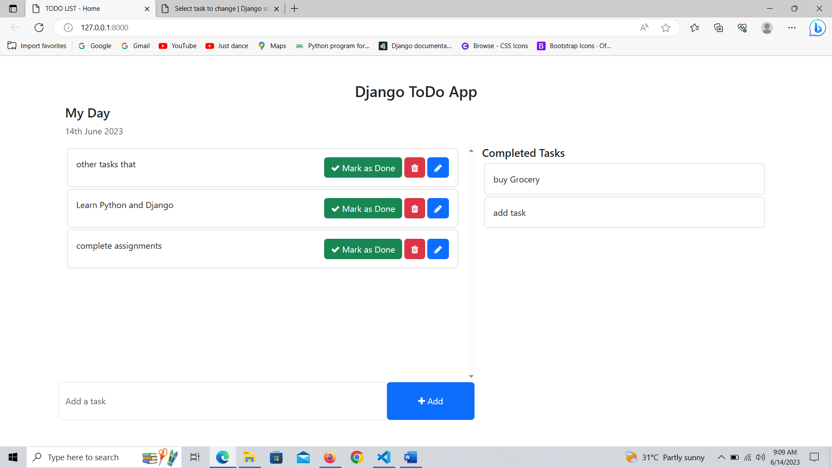

Change in todo app in urls.py

from django.urls import path

from . import views

urlpatterns = [

    path('addTask/', views.addTask,name="addTask"),

    path('mark_as_done/<int:pk>/',views.mark_as_done,name='mark_as_done'),

]

Change in todo app in views.py

from django.shortcuts import render, redirect, get_object_or_404

from django.http import HttpResponse

from .models import Task

def addTask(request):

    task=request.POST['task']

    Task.objects.create(task=task)

    return redirect('home')

def mark_as_done(request,pk):

    task=get_object_or_404(Task,pk=pk)

    task.is_completed=True

    task.save()

    return redirect('home')

change in home.html

<!-- List of all the tasks for the day -->

                {% for task in tasks %}

                <div class="card m-1">

                    <div class="card-body">

                        {{ task.task }}

                        <span style="position: relative; float: right;">

                            <a href="{% url 'mark_as_done' task.pk  %}" class="btn btn-success"><i class="fa fa-check"></i> Mark as Done</a>

                            <a class="btn btn-danger"><i class="fa fa-trash"></i></a>

                            <a class="btn btn-primary"><i class="fa fa-pencil"></i></a>

                        </span>

                    </div>

                </div>

                {% endfor %}

Run the server [TODO LIST - Home](http://127.0.0.1:8000/) (<http://127.0.0.1:8000/>)

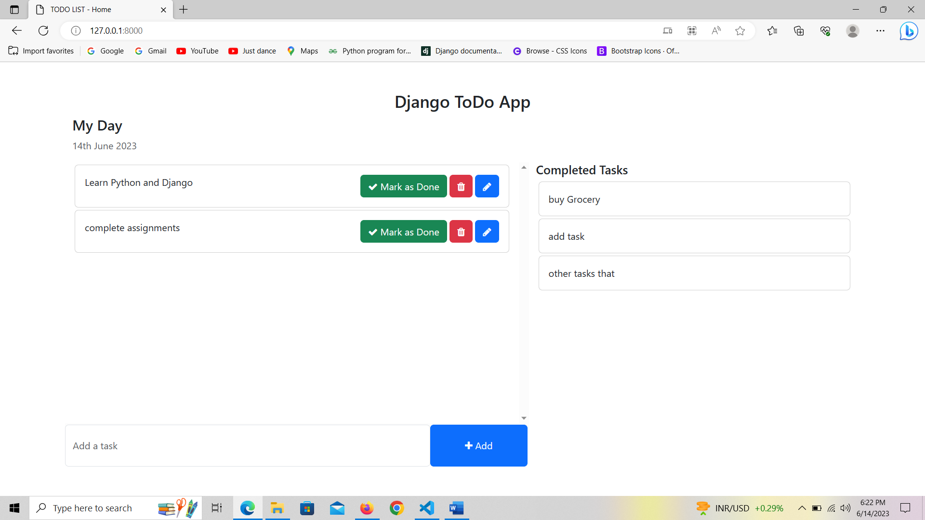

Change in todo app in urls.py

from django.urls import path

from . import views

urlpatterns = [

    path('addTask/', views.addTask,name="addTask"),

    path('mark_as_done/<int:pk>/',views.mark_as_done,name='mark_as_done'),

    path('mark_as_undone/<int:pk>/',views.mark_as_undone,name='mark_as_undone'),

    path('edit_task/<int:pk>/',views.edit_task,name='edit_task')

]

Change in todo in views.py

from django.shortcuts import render, redirect, get_object_or_404

from django.http import HttpResponse

from .models import Task

def addTask(request):

    task=request.POST['task']

    Task.objects.create(task=task)

    return redirect('home')

def mark_as_done(request,pk):

    task=get_object_or_404(Task,pk=pk)

    task.is_completed=True

    task.save()

    return redirect('home')

def mark_as_undone(request,pk):

    task=get_object_or_404(Task,pk=pk)

    task.is_completed=False

    task.save()

    return redirect("home")

def edit_task(request,pk):

    get_task=get_object_or_404(Task,pk=pk)

    if request.method == "POST":

        new_task=request.POST['task']

        get_task.task = new_task

        get_task.save()

        return redirect("home")

    else:

        context={

            'get_task' : get_task

        }

    return render(request,"edit_task.html",context)

Change in home.html

<!-- List of all the tasks for the day -->

                {% for task in tasks %}

                <div class="card m-1">

                    <div class="card-body">

                        {{ task.task }}

                        <span style="position: relative; float: right;">

                            <a href="{% url 'mark_as_done' task.pk  %}" class="btn btn-success"><i class="fa fa-check"></i> Mark as Done</a>

                            <a class="btn btn-danger"><i class="fa fa-trash"></i></a>

                            <a href="{% url 'edit_task' task.id %}" class="btn btn-primary"><i class="fa fa-pencil"></i></a>

                        </span>

                    </div>

                </div>

                {% endfor %}

AND

<!-- List of all the tasks that have completed -->

                {% for task in completed_tasks %}

                <div class="card m-1">

                    <div class="card-body">

                       {{ task.task }}

                       <span style="position: relative; float:right;">

                        <a href="{% url 'mark_as_undone' task.pk %} "class="btn btn-primary"><i class="fa fa-pencil"></i> Mark as Unone </a>

                       </span>

                    </div>

                </div>

                {% endfor %}

Create a file in templates edit_task.html

<!DOCTYPE html>

<html lang="en">

<head>

    <meta charset="UTF-8">

    <meta http-equiv="X-UA-Compatible" content="IE=edge">

    <meta name="viewport" content="width=device-width, initial-scale=1.0">

    <title>Edit Task - Django TODO App</title>

    <!-- Bootstrap -->

    <link href="https://cdn.jsdelivr.net/npm/bootstrap@5.3.0-alpha1/dist/css/bootstrap.min.css" rel="stylesheet" integrity="sha384-GLhlTQ8iRABdZLl6O3oVMWSktQOp6b7In1Zl3/Jr59b6EGGoI1aFkw7cmDA6j6gD" crossorigin="anonymous">

    <script src="https://cdn.jsdelivr.net/npm/bootstrap@5.3.0-alpha1/dist/js/bootstrap.bundle.min.js" integrity="sha384-w76AqPfDkMBDXo30jS1Sgez6pr3x5MlQ1ZAGC+nuZB+EYdgRZgiwxhTBTkF7CXvN" crossorigin="anonymous"></script>

    <!-- Font Awesome Icons -->

    <link rel="stylesheet" href="https://cdnjs.cloudflare.com/ajax/libs/font-awesome/4.7.0/css/font-awesome.min.css">

</head>

<body>

    <div class="container">

        <h3 class="pt-5 pb-5 text-center">Django TODO App - Edit Task</h3>

        <form action="{% url 'edit_task' get_task.pk  %}" method="POST" style="width: 500px; margin:auto;">

            {% csrf_token %}

            <div class="form-group">

                <span style="display: flex;">

                    <input type="text" name="task" class="form-control" placeholder="Add a task" value="{{ get_task.task }}">

                    <button type="submit" class="btn btn-primary" style="width: 200px;"><i class="fa fa-plus"></i>Update</button>

                </span>

            </div>

        </form>

    </div>

</body>

</html>

Run the server [TODO LIST - Home](http://127.0.0.1:8000/) (<http://127.0.0.1:8000/>)

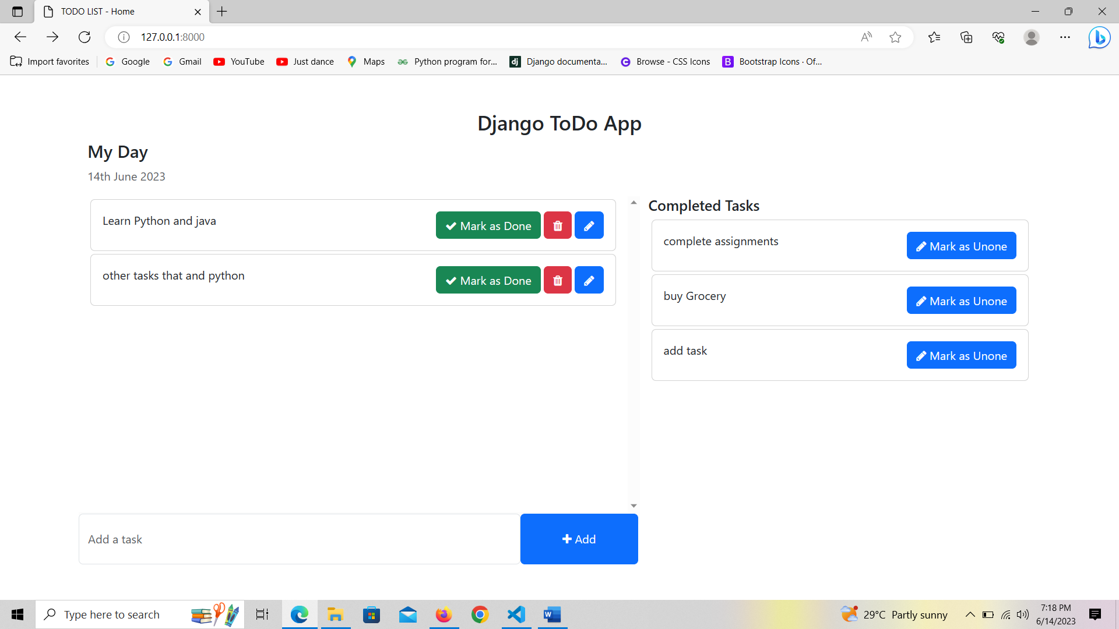

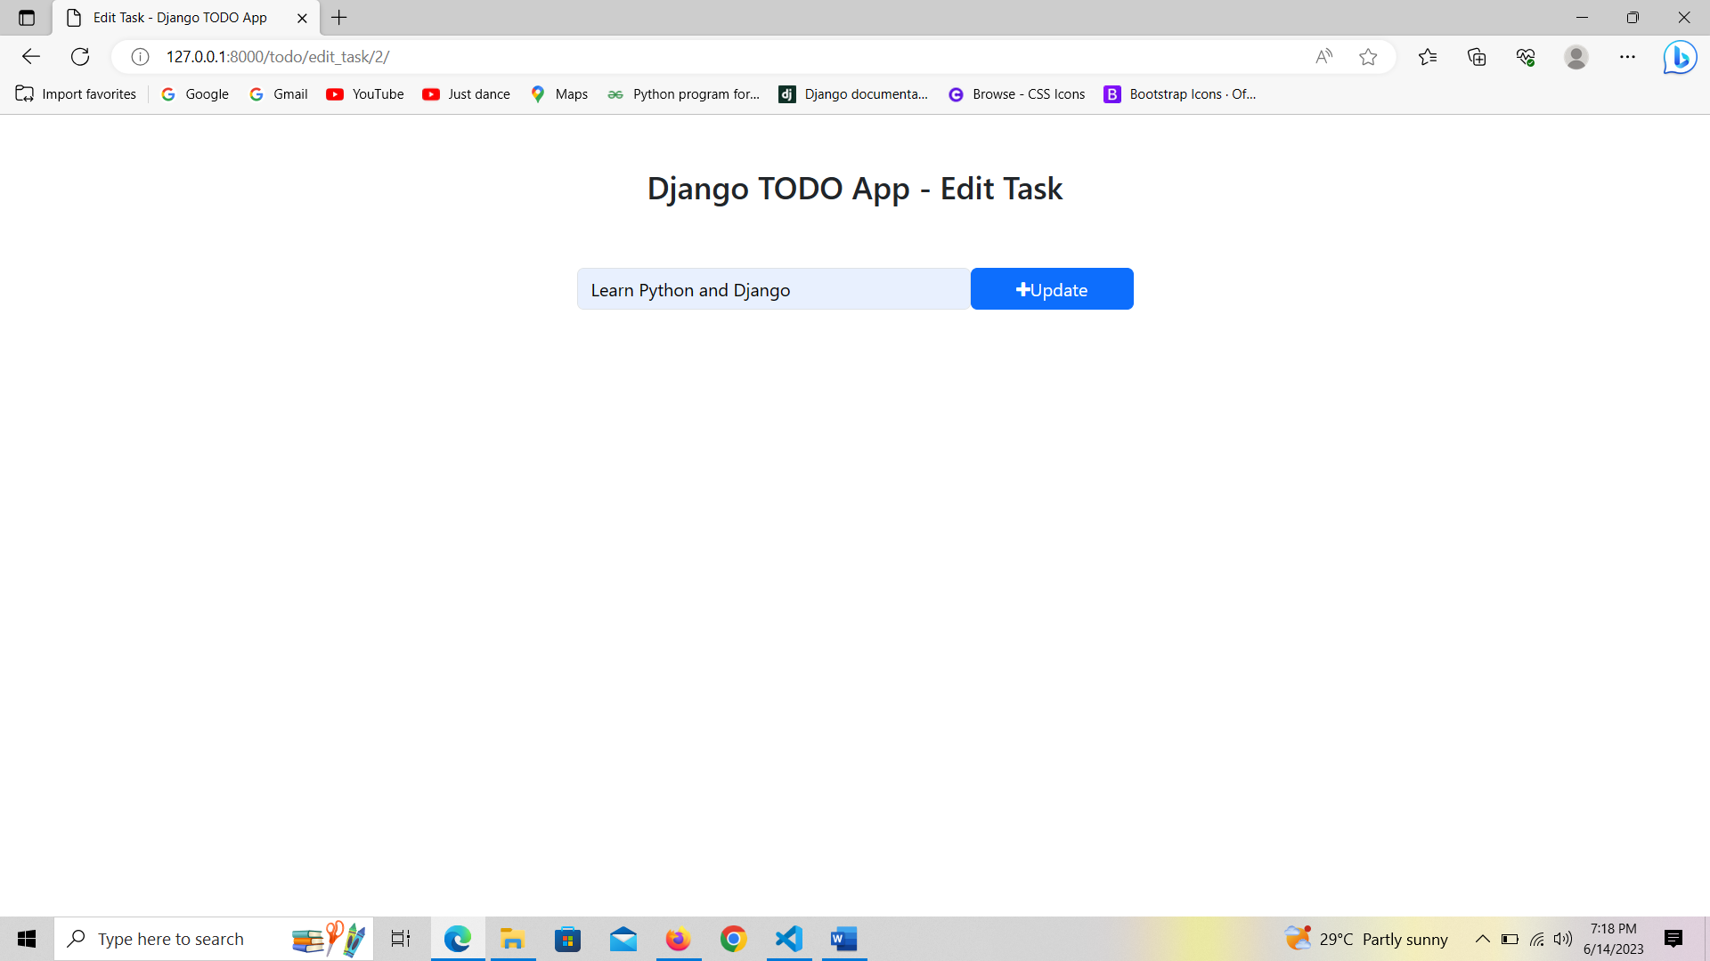

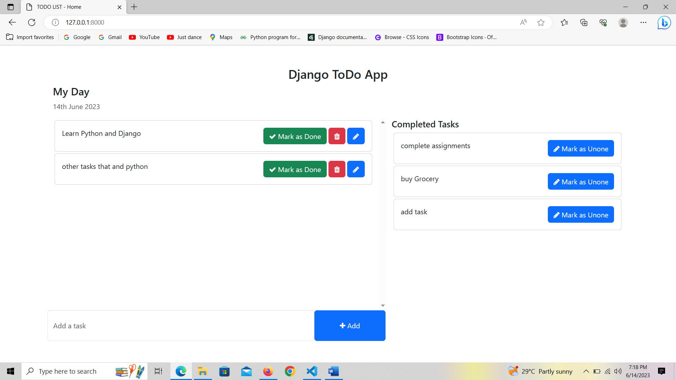

Change in todo app in urls.py

from django.urls import path

from . import views

urlpatterns = [

    path('addTask/', views.addTask,name="addTask"),

    path('mark_as_done/<int:pk>/',views.mark_as_done,name='mark_as_done'),

    path('mark_as_undone/<int:pk>/',views.mark_as_undone,name='mark_as_undone'),

    path('edit_task/<int:pk>/',views.edit_task,name='edit_task'),

    path('delete_task/<int:pk>/',views.delete_task,name='delete_task'),

]

Change in todo in views.py

from django.shortcuts import render, redirect, get_object_or_404

from django.http import HttpResponse

from .models import Task

def addTask(request):

    task=request.POST['task']

    Task.objects.create(task=task)

    return redirect('home')

def mark_as_done(request,pk):

    task=get_object_or_404(Task,pk=pk)

    task.is_completed=True

    task.save()

    return redirect('home')

def mark_as_undone(request,pk):

    task=get_object_or_404(Task,pk=pk)

    task.is_completed=False

    task.save()

    return redirect("home")

def edit_task(request,pk):

    get_task=get_object_or_404(Task,pk=pk)

    if request.method == "POST":

        new_task=request.POST['task']

        get_task.task = new_task

        get_task.save()

        return redirect("home")

    else:

        context={

            'get_task' : get_task

        }

    return render(request,"edit_task.html",context)

def delete_task(request,pk):

    task=get_object_or_404(Task,pk=pk)

    task.delete()

    return redirect("home")

Change in home.html

{% for task in tasks %}

                <div class="card m-1">

                    <div class="card-body">

                        {{ task.task }}

                        <span style="position: relative; float: right;">

                            <a href="{% url 'mark_as_done' task.pk  %}" class="btn btn-success"><i class="fa fa-check"></i> Mark as Done</a>

                            <a href="{% url 'delete_task' task.id %}" class="btn btn-danger"><i class="fa fa-trash"></i></a>

                            <a href="{% url 'edit_task' task.id %}" class="btn btn-primary"><i class="fa fa-pencil"></i></a>

                        </span>

                    </div>

                </div>

                {% endfor %}

Run the server [TODO LIST - Home](http://127.0.0.1:8000/) (<http://127.0.0.1:8000/>)

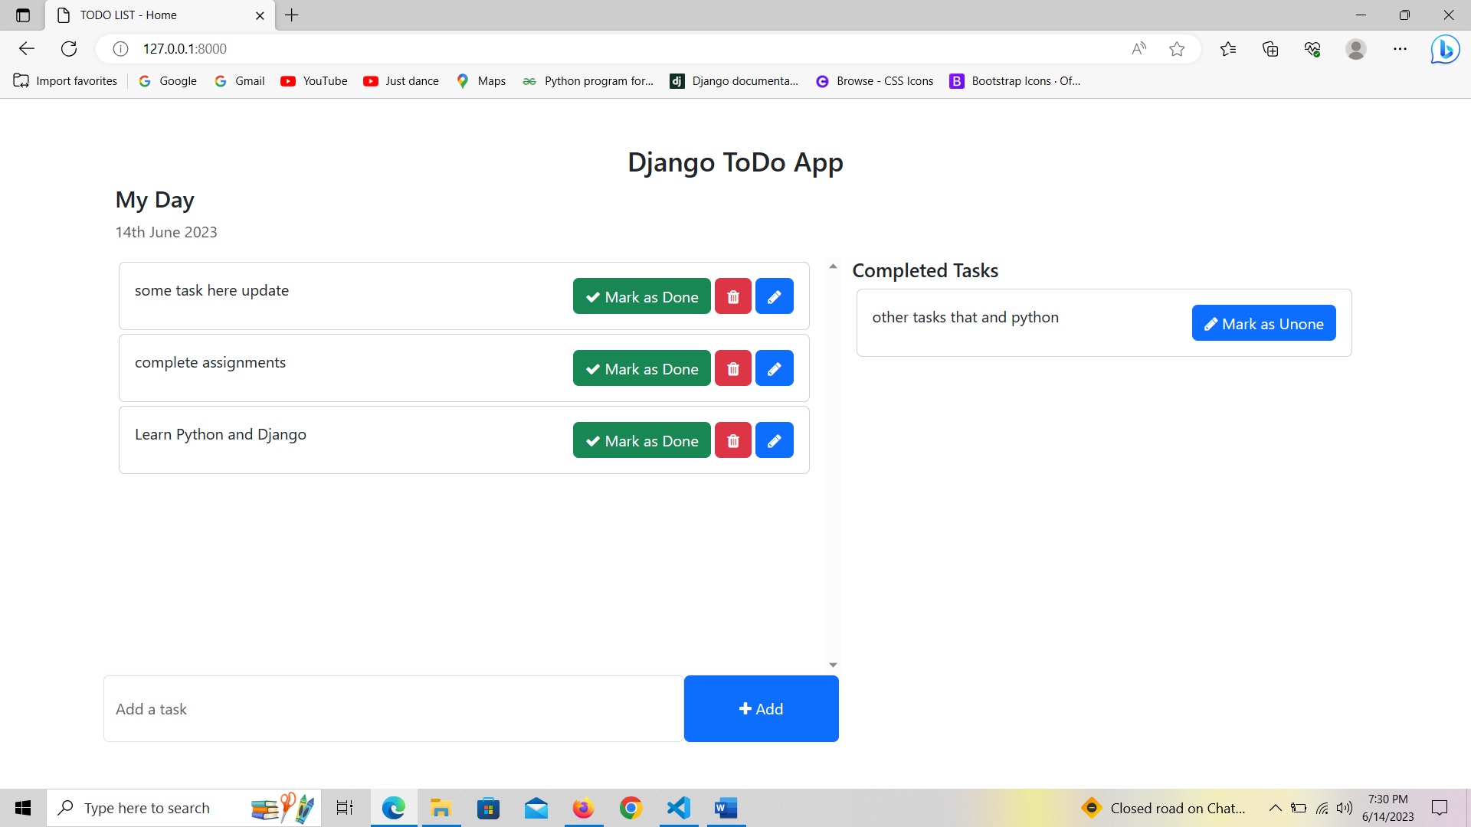

##############################################################################

create github account and sign in

Create a new repository as name todo

Select Private

And create repository

### …or create a new repository on the command line

echo "# todo" >> README.md

git init

git add README.md

git commit -m "first commit"

git branch -M main

git remote add origin https://github.com/hareshvegad/todo.git

git push -u origin main

run **git init** in terminal

run **git add -A** in terminal (“all the file of ToDo in transfer to github”)

run **git commit -m "to do app initialized"** in terminal

run **git branch -M main** in terminal

run **git remote add origin** [**https://github.com/hareshvegad/todo.git**](https://github.com/hareshvegad/todo.git)in terminal

run **git push -u origin main** in terminal

##############################################################